External Documentation

Neil MacKenzie

200249489

COPR

September 27, 2013

**Logo**



Colours: All colours used are in the colour swatch

Table of Contents

Index / Home

Link – Twitter

Link – LinkedIn

Link - GitHub

About Me

My resume

Projects

Link – GitHub Arduino project

Link – GitHub Website project

Link – Canadian supplier of ATX power board

Link – Youtube time lapse video

Link – Youtube time lapse video

Link – Youtube time lapse video

Services

Contact Me

Link – Twitter

Link – LinkedIn

Link – GitHub

Brief Description

An attempt at a clean website using HTML5 and CSS3 with a retro feel.

Navigation Bar



Colours

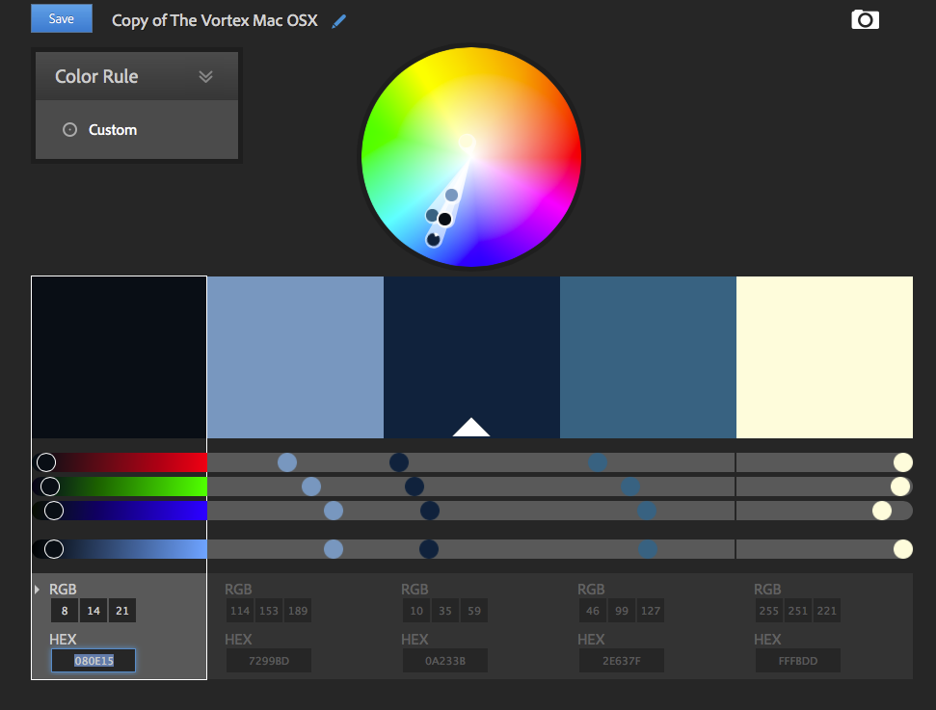

Typography Section



A= HTML generic sans-serif bold

B= HTML generic sans-serif